# **Adidas Sales Analysis**

# **About the Project**

# In the fiercely competitive world of sports apparel, understanding market trends, consumer preferences, and sales dynamics is crucial for staying ahead. Adidas, a global leader in this industry, is no stranger to these challenges. In this in-depth analysis, we dive into a comprehensive dataset to uncover the hidden patterns and strategies behind Adidas’ sales triumphs.

Our exploration reveals fascinating insights into several key aspects: from sales performance and product popularity to regional market variations and efficiency of sales methods. We delve into questions such as which products are leading in sales, which regions show robust performance, and the interplay between profit margins and sales figures.

This Project presents our findings from an exhaustive exploratory data analysis (EDA), offering a rare glimpse into Adidas’ business strategies. Whether you’re a marketing professional, a data enthusiast, or simply a fan of the brand, join us in uncovering the secrets behind Adidas’ success story, one data point at a time

**Project Overview**

**This project aims to provide a thorough analysis of Adidas’ sales performance and market presence. Utilizing a detailed dataset, the project explores various facets of the business, including sales trends, product popularity, regional market performance, and more.**

**Requirements**:

For this project, we utilized the “Adidas Sales Dataset” from [Kaggle](https://github.com/prayagpadwal/Adidas-Sales-Analysis), in XLSX format. Analysis was performed using VS Code Python environment, complemented by Tableau for creating interactive dashboards. The dataset, organized in an Excel spreadsheet, includes the following columns:

* **Retailer:** Names such as Foot Locker, Walmart, Sports Direct, and West Gear.
* **Retailer ID:**A unique identifier for each retailer.
* **Invoice Date:**The date the invoice was generated.
* **Region:** Geographic areas like West, Northeast, Southeast, South, and Mid-west.
* **Product:** Categories like Men’s and Women’s Street and Athletic Footwear, and Apparel.
* **Price per Unit:** The cost of a single item of a specific product.
* **Units Sold:** The quantity of a product sold in a specific timeframe.
* **Total Sales:** The total revenue from sales over a certain period.
* **Operating Profit:** A measure of the profitability from the main business operations.
* **Operating Margin:** A ratio indicating the profitability of the business operations.
* **Sales Method:** The channels through which sales were made, including In-store, Outlet, and Online.

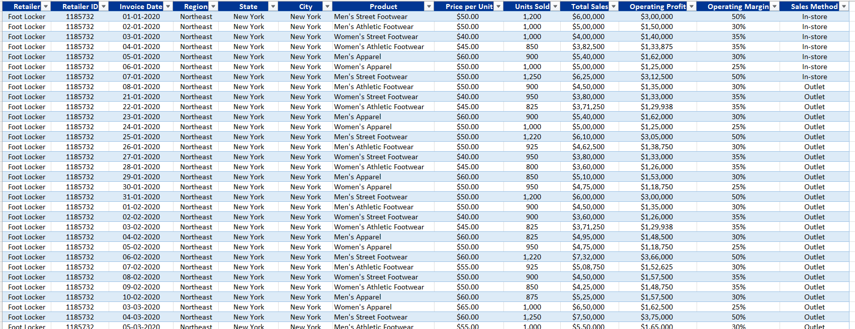**Business problems that can be solved using this dataset:**

**1. Sales Performance Analysis: Which products are excelling in sales, and which are underperforming?**

**2. Regional Market Analysis: Which stores are experiencing strong sales, and which ones are lagging?**

**3. Profit Margin Analysis: Does the profit margin significantly impact sales?**

**2. Regional Market Analysis: Which stores are experiencing strong sales, and which ones are lagging?**

**3. Profit Margin Analysis: Does the profit margin significantly impact sales?**

**4. Efficiency of Sales Methods: Which sales method is more effective — in-store or online?**

**5. Price Optimization: Is there a specific price range that achieves better sales than others?**

**6. Product Portfolio Optimization I: Determine which products are most profitable, segmented by location.**

**7. Market Expansion Opportunities: Assess the best and worst performing stores based on their locations.**

**8. Time Series Analysis: Investigate whether there has been a consistent sales trend over time or any noticeable monthly trends.**

**9. Predictive Sales Analysis: Develop a forecast for monthly sales.**

**10. Power BI Sales Dashboard**

# **Project**

**Data Cleaning and Pre-Processing**:

**Tools used: My SQL, Excel and Power BI**

**SELECT * FROM db_adidas.adidas_sales;**

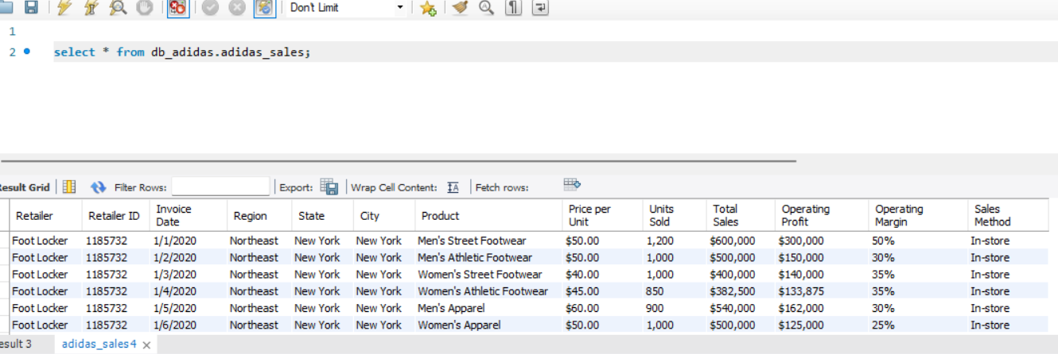***Checking for Null values using MYSQL:***

***SELECT count(*) FROM db_adidas.adidas_sales where Product is null;***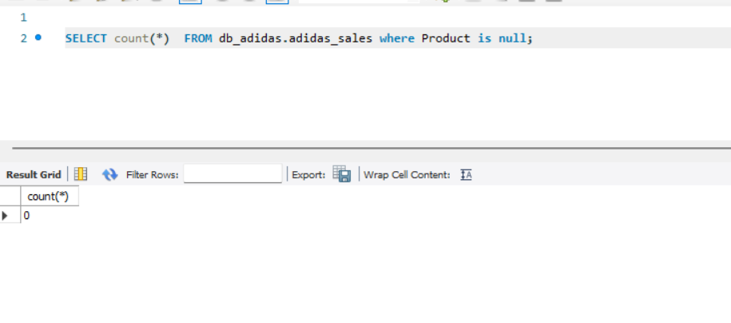

* ***NO null values are counted in the data set using MYSQL .***

***Checking for duplicates:***

***SELECT Product,Retailer, COUNT(*) AS duplicate_count***

***FROM adidas_sales***

***GROUP BY Product, Retailer***

***HAVING COUNT(*) > 1;***

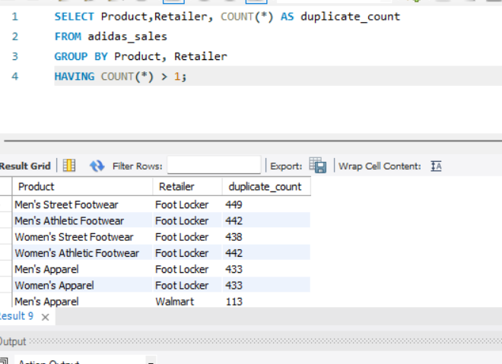

* ***Except retailer Id all columns are duplicated, it is a primary key for the table.***

***Data analysing Using MYSQL***

***select distinct(Product) ,count(*) from db_adidas.adidas_sales group by Product***

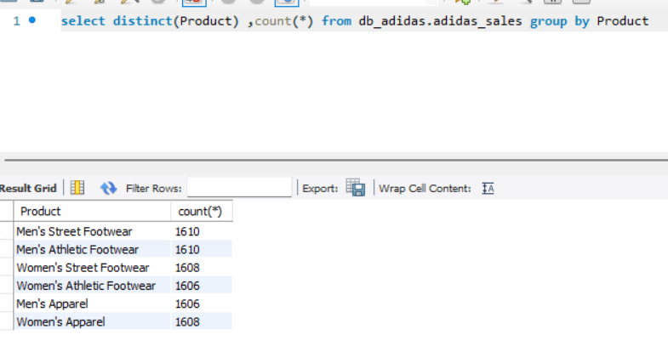

* ***Product has 6 unique values in the Adidas Sales table;***

***Checking for unique regions where sales are generated***

***select distinct(Region) ,count(*) from db_adidas.adidas_sales group by Region***

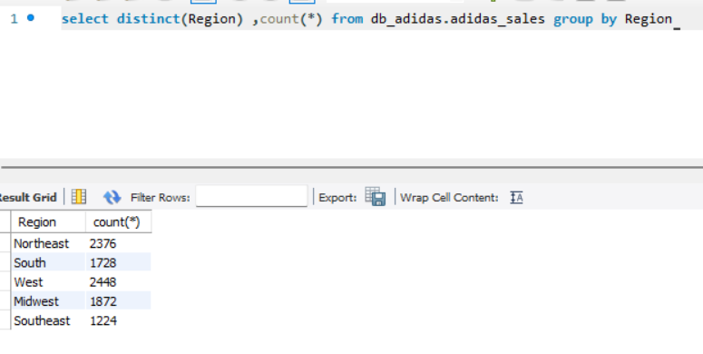

***Adidas has Five Regions for sales : North East, South, West, Midwest and South East.***

***Sales Analyis with Excel:***

***Sales by Product wise :***

|  |  |  |
| --- | --- | --- |
| ***Row Labels*** | **Sum of Total Sales** | **Sum of Units Sold** |
| *Men's Apparel* | 123728632 | 306683 |
| *Men's Athletic Footwear* | 153673680 | 435526 |
| *Men's Street Footwear* | 208826244 | 593320 |
| *Women's Apparel* | 179038860 | 433827 |
| *Women's Athletic Footwear* | 106631896 | 317236 |
| *Women's Street Footwear* | 128002813 | 392269 |
| ***Grand Total*** | **899902125** | **2478861** |

***Total Sales***

|  |
| --- |
| **Sum of Total Sales** |
| 899902125 |

***Sales by Month***

***Profit by month***

***Top Units sold by State***

***Sales by State***

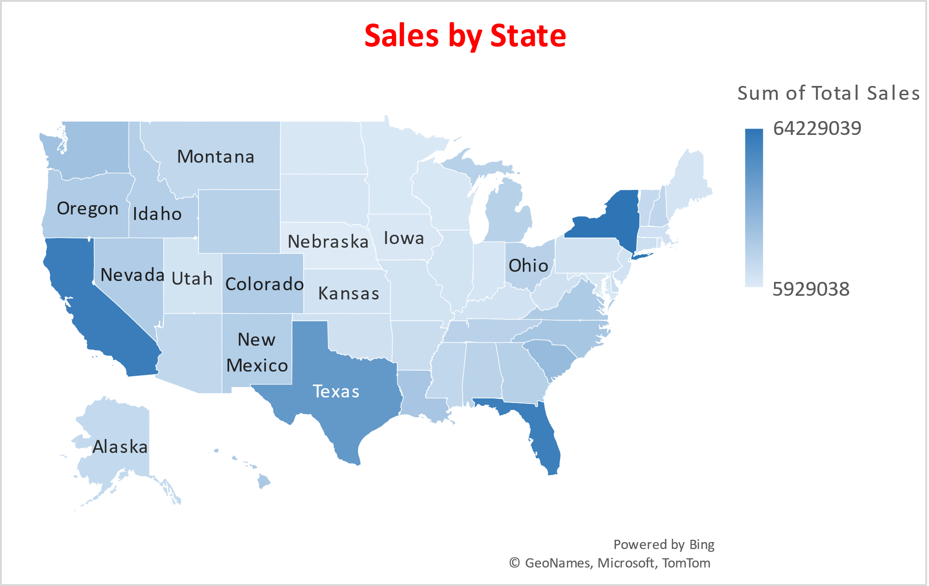

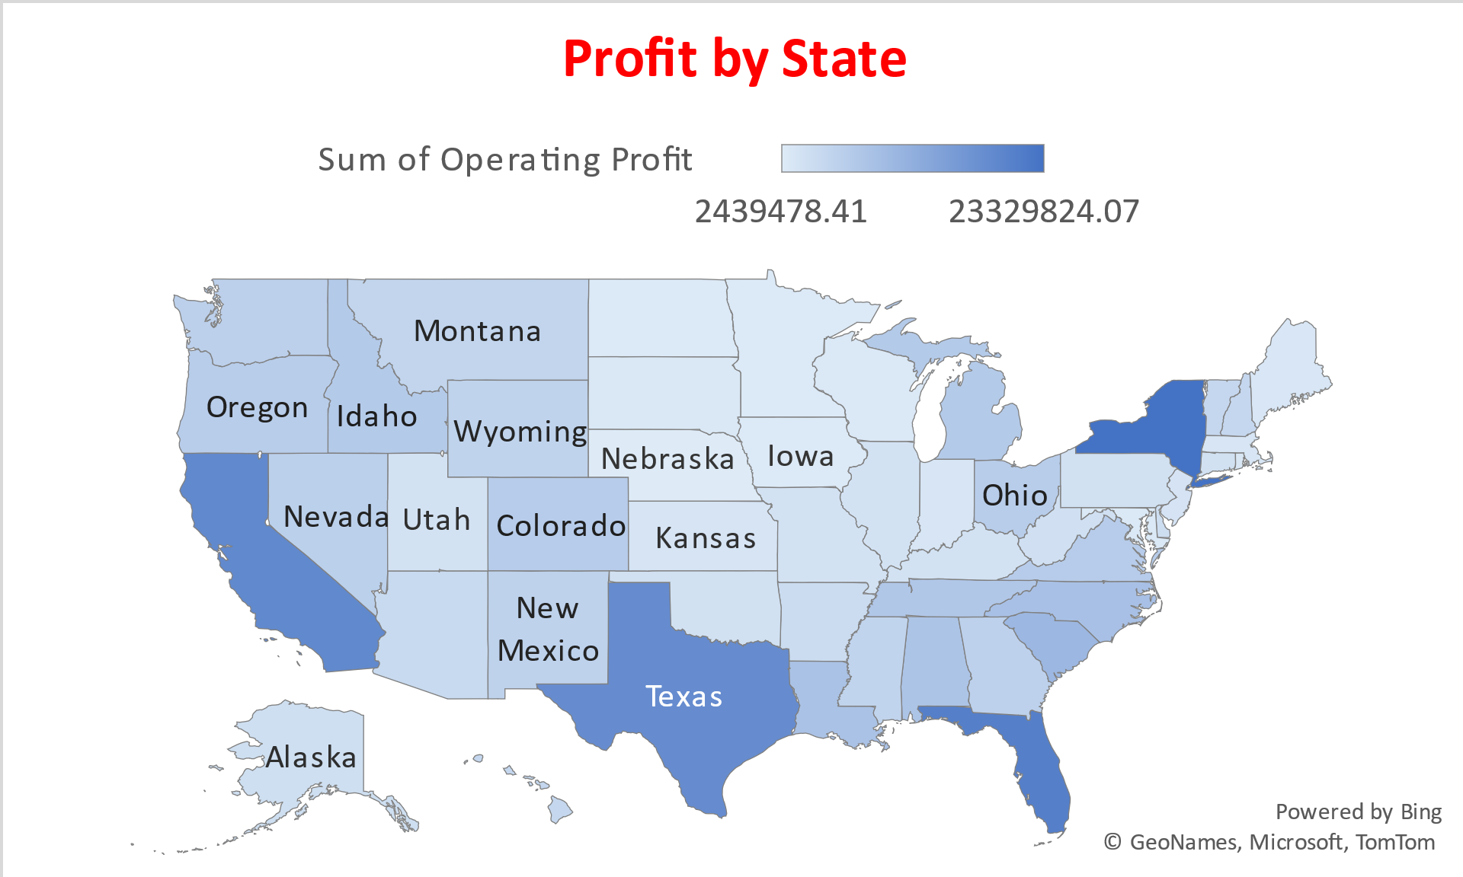

***Dashboard with Power BI***

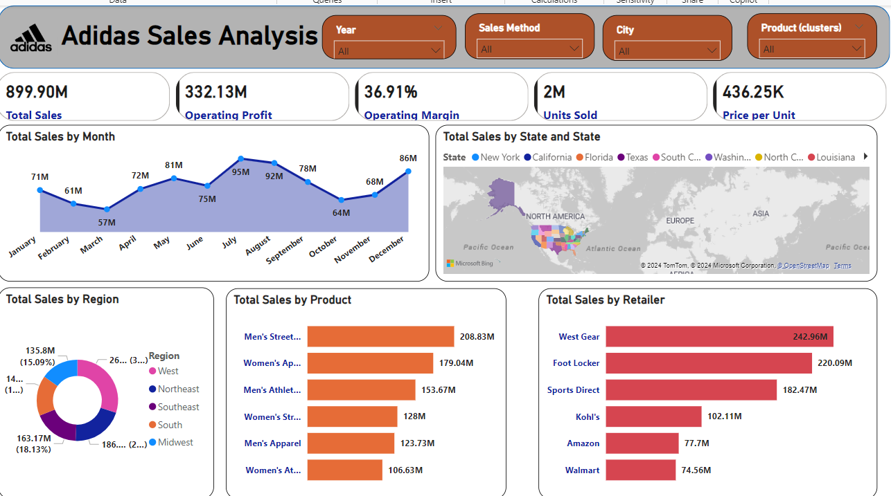

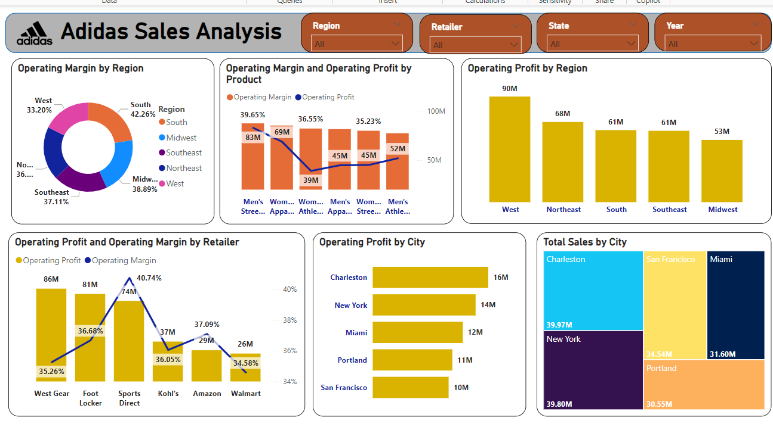

***Key insights***

 Here are the key insights:  
🔍 Retailer Insights:  
West Gear stood out with the highest Operating Profit at ₹8,56,67,873.18, a staggering 232.28% higher than Walmart, which had the lowest Operating Profit at ₹2,57,82,052.61.  
The divergence between Operating Profit and Operating Margin was most pronounced with West Gear, where the Operating Profit exceeded the Operating Margin by ₹8,56,67,872.83—indicating a substantial gap.  
West Gear contributed to 25.79% of the overall Operating Profit, positioning it as a key driver of performance.  
Across all 6 product categories, Operating Margin ranged from 33.74% to 39.65%, while Operating Profit spanned from ₹3,89,75,784.94 to ₹8,28,02,260.62, reflecting varying performance across product lines.  
📅 Monthly Sales Insights:  
July led with the highest Total Sales of ₹95,48,06,694, marking a 68.07% increase compared to March, which had the lowest sales at ₹56,80,91,109.  
July alone accounted for 10.61% of the Total Sales for the year, showing a strong mid-year performance.  
Total Sales over the 12-month period ranged from ₹56,80,91,109 to ₹95,48,06,694, revealing seasonal sales fluctuations that can be leveraged for future strategy.  
🌍 Sales Insights by Region:  
West region accounted for 25.4% of total sales, while the South region followed closely with 17.9%, showcasing the geographical distribution of Adidas' sales performance. These regions play a significant role in overall growth, and understanding their performance can drive targeted strategies for each market.